**Reverse a Linked List**

**Java**

Reverse a Linked List without using extra space.

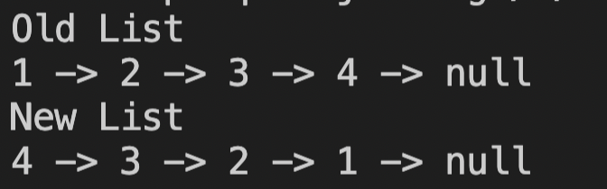

**Iterative Method**

Time complexity - O(n)

Space complexity - O(1)

**public void reverseList() {**

**if(head == null || head.next == null) {**

**return;**

**}**

**Node prevNode = head;**

**Node currNode = head.next;**

**while(currNode != null) {**

**Node nextNode = currNode.next;**

**currNode.next = prevNode;**

**prevNode = currNode;**

**currNode = nextNode;**

**}**

**head.next = null;**

**head = prevNode;**

**}**

**Recursive Method**

Time complexity - O(n)

Space complexity - O(1)

public Node reverseListRecursive(Node head) {

//empty node || last node or only one node

if(head == null || head.next == null) {

return head;

}

Node newHead = reverseListRecursive(head.next);

head.next.next = head;

head.next = null;

return newHead;

}

**Collections Method**

Time complexity - O(n)

Space complexity - O(1)

**LinkedList<Integer> list2 = new LinkedList<>();**

**list2.add(1);**

**list2.add(2);**

**Collections.reverse(list2);**

**Homework Problems**

1. <https://leetcode.com/problems/swap-nodes-in-pairs/>
2. <https://leetcode.com/problems/remove-nth-node-from-end-of-list/>
3. <https://leetcode.com/problems/reverse-linked-list-ii/>
4. <https://leetcode.com/problems/remove-nth-node-from-end-of-list/>